Jenkins is a free and open-source continuous integration tool, which is used for:

* Continuous build
* Continuous deployment and
* Testing

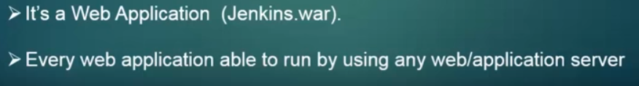

Here we are going to use a tomcat web server to install the Jenkins.

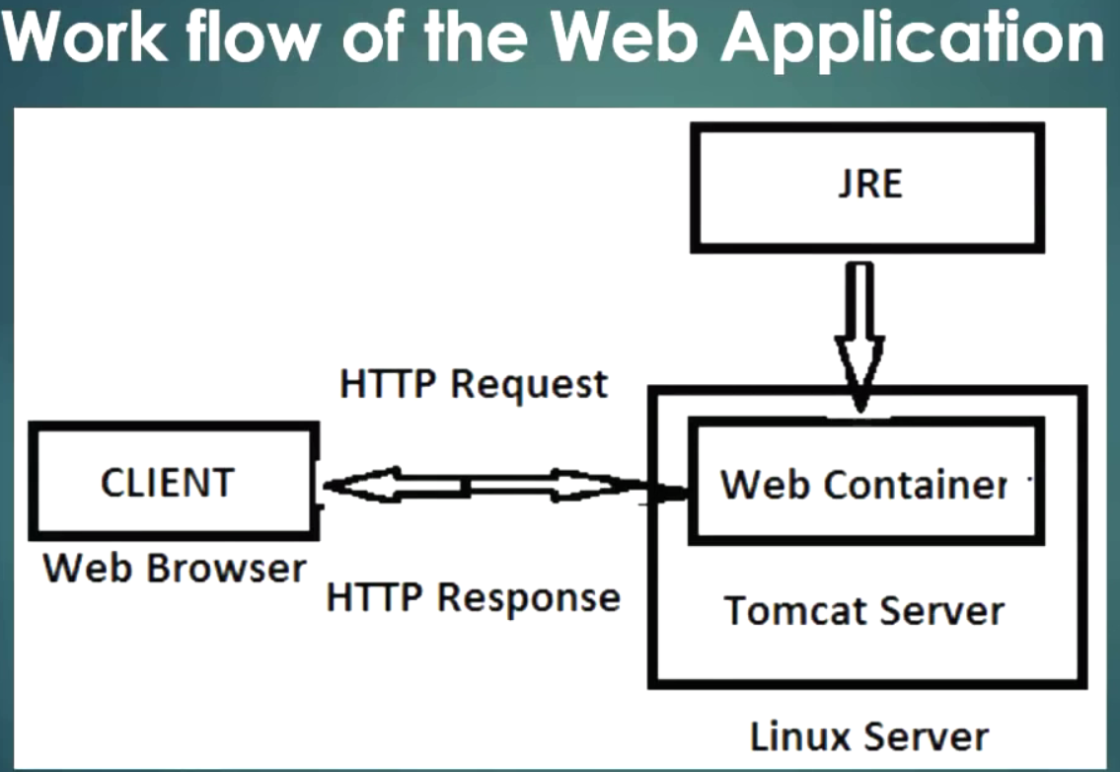

Client/Web Browser: google chrome, Mozilla Firefox or internet explorer or opera.

tomcat server: this is my Linux operating system and in that i've installed installed Tomcat server in linux OS. In Tomcat server, there is a container called Web container/JSP servlet container.

Internally tomcat will use JRE java runtime environment.

JRE is having JVM- java virtual machine

it is used to convert code from byte code to machine understandable language .

That means we have wrote the java code and that after compiling the java code, it will converted into Java byte code. The Java byte will be executable by using the jvm only .So jvm will be available in JRE.

So tomcat will internally access JRE and JRE will have the jvm to execute/translate byte code to machine understandable language.

So basically what will happen if we want to access the web application??

1. First when our client make requests to the web server through our HTTP or HTTPS .

If you send a request from the client, that web container, tomcat server will search for web application .Whatever request you made to the server ,it will the search and it gives response back to the client.

So if you want to install Jenkins, you will need a web browser, Tomcat server, JRE.

Winscp: ftp file transfer protocol

Sftp: secure ftp

Scp: secure copy---best and high sceure

Netstat –anp | grep –in java

IP :port number-> to access that apache tomcat server

To access the Jenkins application -🡪 / then enter context context .

Context is nothing but a specific application. If you want to access some particular application that are available in the web apps folder. You can use it by mentioning / Jenkins custom

Login to your tomcat manager apps. It will ask for that authentication then you need to give your username and password.

War file--🡪 Deploy …After logging into, here you will find that Jenkins

So whatever application available in webapps directory, it will be shown here.

Creating jobs in the Jenkins:

first of all …configure (manage Jenkins🡪 configure system-🡪 )

1. Java

echo $JAVA_HOME

1. 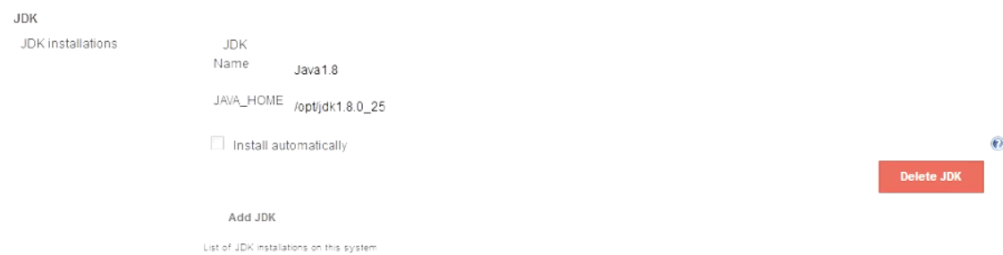 ant.

echo $ANT_HOME

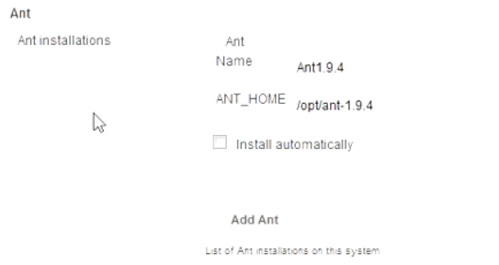

Note: Verify .Jenkins folder while doing this.

We can see some files are created here…

New item->Demo Project-> Freestyle project (example)

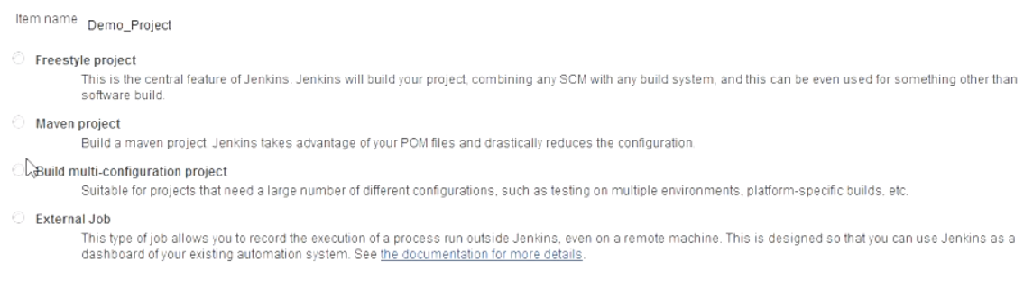

**Now, here comes Configuration part of Job:**

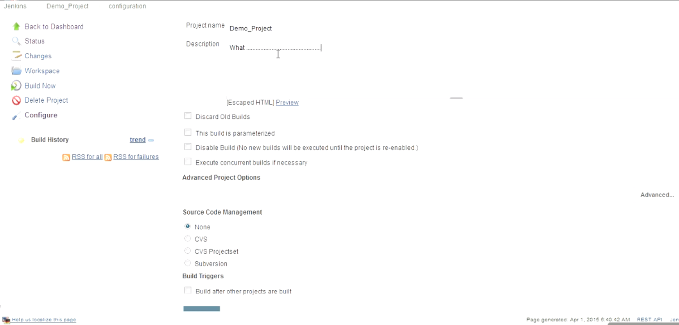

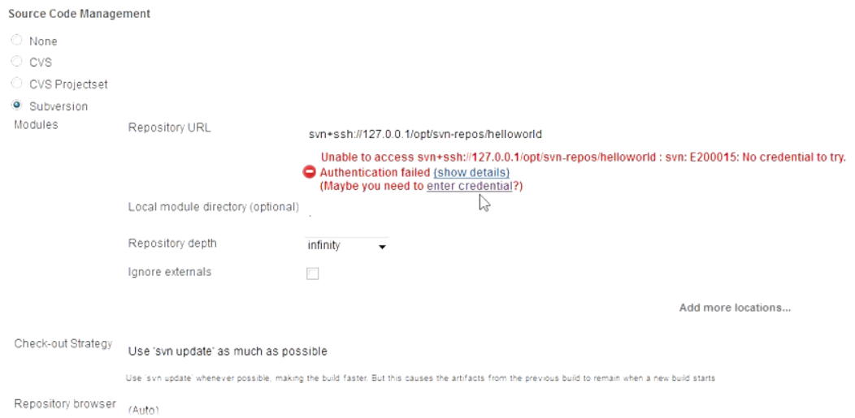

**SVN authentication**

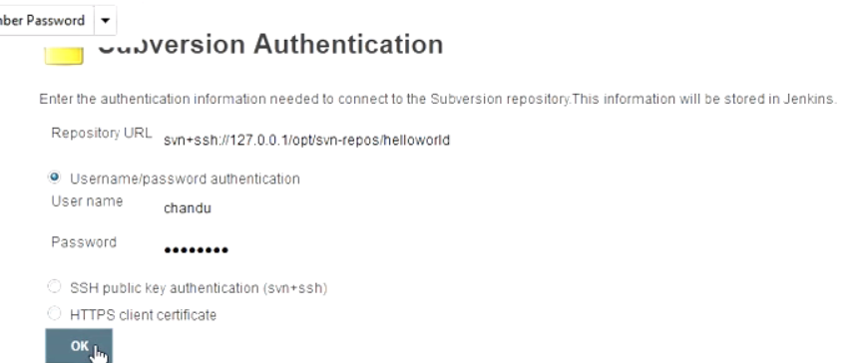

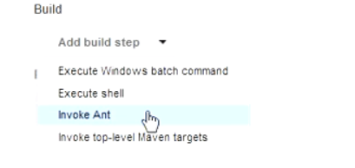

**Invoke ANT--🡪 select version of ant,other than default**

**BUILD.xml**

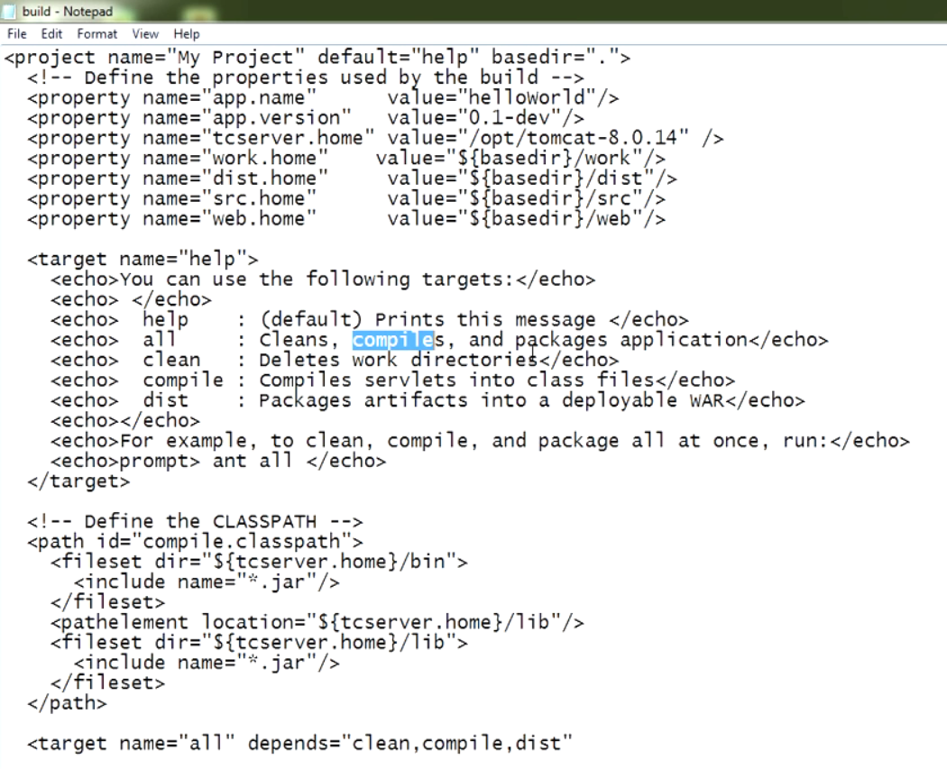

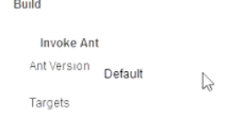

**In this ant script , we have different targets: help, all, clean etc**

**By default: help target will be executed.**

**By executing help, we get messages (2).**

**We need to compile soucce code, and package it. We need to get artifact of war file.**

**So, if u need to get project war file, we need to execute all tagets.**

**All: Clean wks ,compile, package to war.**

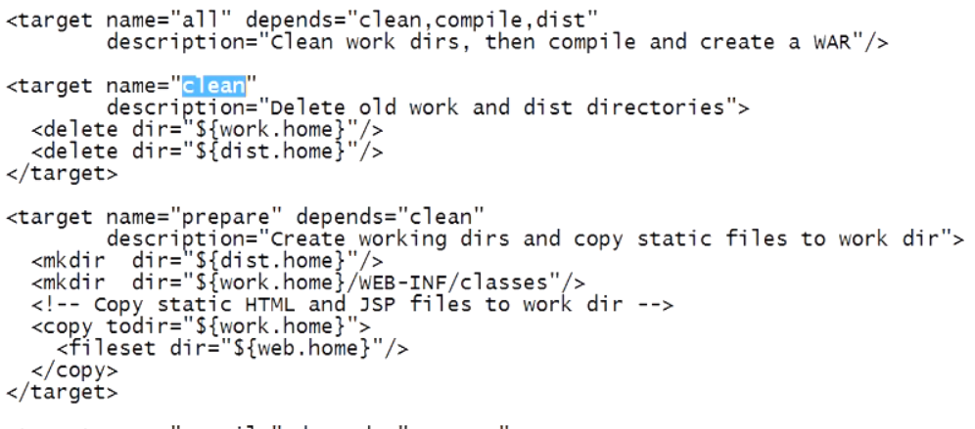

**Prepare: clean should be executed before**

**Clean: Dir will be deleted.**

**Depending on script, we need to call target**

**Invoke ANT default**

there are several types of projects will be labeled like that please Dale and mavin and multi configurations external sign some other will be here if you install the plug-in the later sections i will explain about all the things as of now just a week and we should go with we are creating its engaging in jail right so for that i'm going with the crystal project so this is the configuration page of the job here regarding the project name and then the description who r description you want to give it will be so just right to vote for lunch about your project and this will be that some options of the James job and they may not require it so we're really in the v8 is a complex Billy visual use it but I'm going with this important right so that Lang going to the source for sm management so in the same management body part ii CBS and these three things will be available ready for Utley and if you want to use that gift and purpose you need to install the plug-in subject to use it so i am going with the free and open source is a subversion svn so here so this is my repository this proposed that is having the project called hello world so I want to use that here so far that i need to pass the year i love a lower project this year ends Sen place as a search this is the protocol we are using and then use the localhost or else you can pause the IP address of duct system 1 10 100 . one already I think so IP address of the system and then where our repository and the project is existed so this is the part / <month> May </month> / Sen iphone travel / LOL then once if you can't see if you entered this pot then a the last we will show the error message so in that area to indicated shield option so here he click on this this video another page then there will be a sub watching authentication so if you want to access this repository you need to have you will have you need to have that authentication authorization and have an authorizer person and so I'm going to use my username and password to access the repository so just you use the username and password to connect to do this is this input authentication mechanism other than that there will be a day that my phone is on so then i will explain you so then asian was successfully if you get this measure that means I crisis they are you next to go to the middle section so later with the ability to design this lob lob stop and now anger into the middle section in the business section I had a blister so in the bill stepp already helped configure the hand so we need to invoke it means already if you configure the part where they use in their whatever the job you are considering you need to involve that and torsion and I and descriptive widely if you click on the ask will invoke and then it will give you two options do the default the defaults mean what about default and is existed that will be used so our i'm not one to leave the default so I'm already given them some name right and one by men . so i'm using that and election then what are the targets we need to use here so what of the targets for big so i already have to go to my core from the svn repository here a lower project so in that 1i have a business trip to build script analysis nothing but in and script so I'm opening with here in this Santa script to be a very different too so what are your Star label help land already in compile this so help possible by default will target will be future if you call this and script there by Department help you target will be excluded so by excluding the help you will get this message is on but we need to compile the java source code and you need to package it as I and we need to get the artifact opposite who are . so if you want to get our product our backs ooh so you need to explore the altar here so I'll not get me what me what it will do is it will clean the workspace and compared the java source code and you can create the it will bind our build the project . that's late water jharia like now just for on it this is the target name on the offense our defense equal to clean come by land is too so the before exploding all it will be established should be neutered first so if it is go 14 section Sookie a target will be exposure but before me then our third offense sword prepare to target so this is also one of the target in this section in this business trip if you want to export to prepare target first before better clean should be executed so if you clean is the computer then this directive will be deleted so depending on the script we need to call the target r and r according to your requirement will just go to the gym constructor now I'm more bossing on all means complete what building process will be done next to force to be elections first big flag since nothing but it after your belief succeeded then you will have to get some modifications it build fails you need to get some modification and depending the our documentation like that options will be there I will experience the next section so click on the Save button the job configurations with visual so here you will be given to get the project and what its name and here you will get the description of the project what you have written in the description section and this is the workspace workspaces nothing buddy project to won't have any work space means we have this is a new generation said all right so I don't know till now we did not contribute any jobs means we have continued job but we need a not executed so until that you want to get any work space right so more simply came shit unless God Jenkins that gentleman's if you are go to the dodgin its directly you might be it might hear you want to get any workspace directory right so it was not creative if you click on the building on then it will create of our past time now just to even very irritated or some options in the left panel in this session is to click on de build a no option it will finish it don't mean shit is going to be suited now the building process going on here pasta water even do is check out that for school and positive source for from them subversion repository so here in the sem proposed in the sem reports repositories a lower product is dat so whatever that quote contains the content hello world that will be checked coat from day yes um here and then it will be the legs go to the and script according to an escape the building process will be done so the building's succeeded mean she didn't get any red marks here now you can click on our don't drop like a problem then you will get it comes alone without changes something like that models we go with the by clicking on the button so be it was done so this is the pass to Bill there's very gate one number and this is a date and time of your building and this is that religion so what representing the in the aacn started write an anonymous user means Jenkins does not have any use of right now we have not created any users in the Jenkins persuade issuing an almost user next to console output if you work on load book so who started it an anonymous user and the building that in workspace so what are the very clean the agent so once been restarted automatically once vertically will be created in the large engine section so he regard that works with in the workspace directory you will hear you will have the source for means check out the core you did and they didn't do the next visit and then once press it is create a part of it he created that again the cleaning directive or if there are any water bills means if you run 3-4 business previous building and i'll see to go to check out your files will be there right so that will be clean and this is that check out URL of this repository and check out time and this is that religion and a lot of the final circle from that this when you go from the svn tool now this is that build escape to build effective in the hello world directory that really a file called bill . xml this is nothing more d-day for dance hip then this is the pasta target gene is executed and then prepare anything put it in the prepared section this directly see are created and someone file is copied to this place to this place and then compiled section in the compile targets java file says camp i landed java sea by using the Java Sea comment the file sorts was compiled and it was sent to somewhere else here so that here and then bitch - this is also one of the target so this district that this tutorial part one is created by using georgia and all always exposure right and build a successful building has taken three seconds of time and finally successful now he will get relegated water friends so very well we will find means in the workspace or product name will be displayed to see it is the engines so that students face workspace so in the workspace them about the genetically available in the demo project so we have them and artists and artists and means once you to grow automatically it is there it will be created for the configurations of ESPN and this is the source on source and as well let's grab this directly sir check check out from the svn repository and build a deck sir malala's handle this directly and work directly with a generator building script so these two variables are created here so that is showing and then haha in the rigid ethically district directly our contract is our label so let's feast now brought it just so attractive so our file is available so Billy sex ed right now ok so this is the this is how we can figure and we'll configure the job centre on the jobs in the gentle said work so in the later section i will show you how to configure the jenkins said what means like users and administrators important as the less complex bills and probably types thank you for watching have a mess